Types of wheels used in Robotics for different-different applications, Power electronics.

What is a Wheel in Robotics?
A wheel is a round, circular mechanical component that rotates around its center axis. In robotics and vehicles, wheels are used to provide smooth and efficient movement on a surface like the ground, floor, road, or even special terrains.
A wheel helps the robot roll instead of sliding, which reduces friction and makes movement faster and easier.
How a Wheel Works in a Robot
In robotics, a wheel is usually connected to a motor. The motor provides rotational motion (spinning motion). When the motor rotates, the wheel also rotates, and because the wheel touches the ground, the robot moves forward or backward.
Example:
If the wheel rotates clockwise → robot moves forward
If the wheel rotates anticlockwise → robot moves backward
Types of Wheels Used in Robotics
Robots use wheels as a locomotion system to move from one place to another. The type of wheel selected depends on:
- surface condition (smooth floor / sand / grass / rocks)
- robot weight (lightweight / heavy load)
- required movement (only forward-backward / sideways / diagonal)
- speed requirement
- cost and complexity

Standard Rubber Wheel (Normal Wheel) :
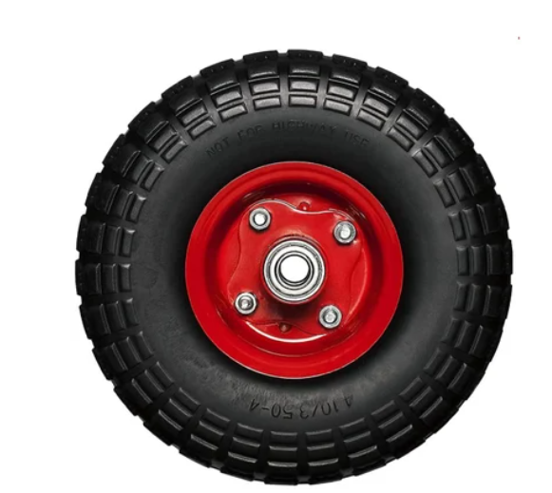
Standard rubber wheels are the most common wheels used in robotics. They are circular wheels made of rubber, plastic, or rubber-coated plastic. These wheels are directly connected to a motor shaft or gearbox.
Rubber wheels are used because rubber provides high friction, which means better grip.
When the motor rotates, the wheel rotates. Because the wheel is in contact with the ground, the friction between the wheel and ground pushes the robot forward.

Features
- Very simple design
- Good grip on smooth surfaces
- Available in different sizes (small, medium, large)
- Can carry moderate load
- Low cost and easily available
Advantages
- Easy to install and maintain
- Stable motion on flat surface
- Works well for beginner robotics projects
- Good efficiency (less power loss)
Disadvantages
- Not good for rough terrain like sand or rocks
- May slip if the surface is wet or dusty
- Not suitable for sideways movement
Applications
- Line follower robot
- Obstacle avoiding robot
- Arduino robot car
- Small delivery robots
- Educational robotics projects

A robot vacuum cleaner uses rubber wheels because it moves mostly on smooth indoor floors.

2. Caster Wheel
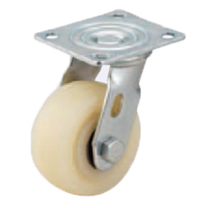
A caster wheel is a free rotating wheel used mainly for balance. It is not connected to any motor. It is normally used as the third wheel in a 3-wheel robot design.
Caster wheels are often made of plastic or metal and can rotate 360 degrees.
Caster wheel moves automatically in the direction the robot is moving. It reduces friction and supports the robot body weight.
Features
- Rotates in any direction freely
- Provides balance and support
- Very cheap and simple component
- Reduces load on motor wheels
Advantages
- Easy to use in robot design
- Helps robot turn smoothly
- Improves stability in 2-wheel robots
Disadvantages
- Not good for uneven surfaces
- Sometimes gets stuck on obstacles
- Can wobble at high speed
Applications
- 2-wheel differential robots
- Line follower robots
- Small robotic cars
- Indoor service robots
3. Omni Wheel
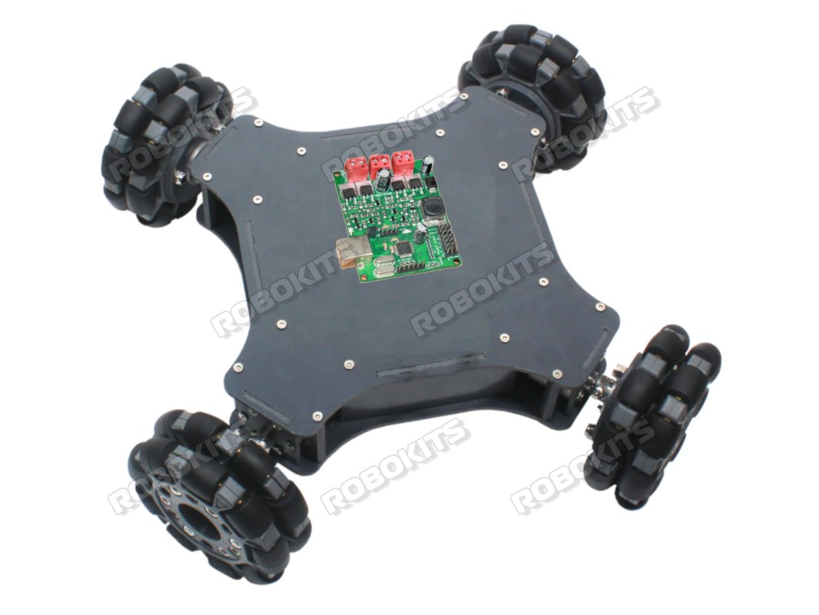
Omni wheels are special wheels with small rollers placed around the wheel’s circumference. These rollers allow the wheel to move sideways with very low resistance.
That is why omni wheels are used when robots need multi-direction movement.
The main wheel rotates in one direction, but the rollers rotate sideways. This reduces sideways friction and allows the robot to slide left or right.
Features
- Allows sideways motion
- Smooth turning and easy direction change
- Requires special wheel arrangement (3-wheel or 4-wheel omni setup)
- Works best on smooth surfaces
Advantages
- Multi-direction motion possible
- Very useful in indoor robotics
- High maneuverability (easy to change direction)
Disadvantages
- Low traction compared to rubber wheels
- Not suitable for outdoor or rough surface
- Slips easily on uneven ground
Applications
- Service robots
- Indoor warehouse robots
- Hospital robots
- Robot soccer competition robots
Real World Example
Robots in competitions like RoboCup use omni wheels for fast movement and sudden direction changes.
4. Mecanum Wheel (Holonomic Wheel)
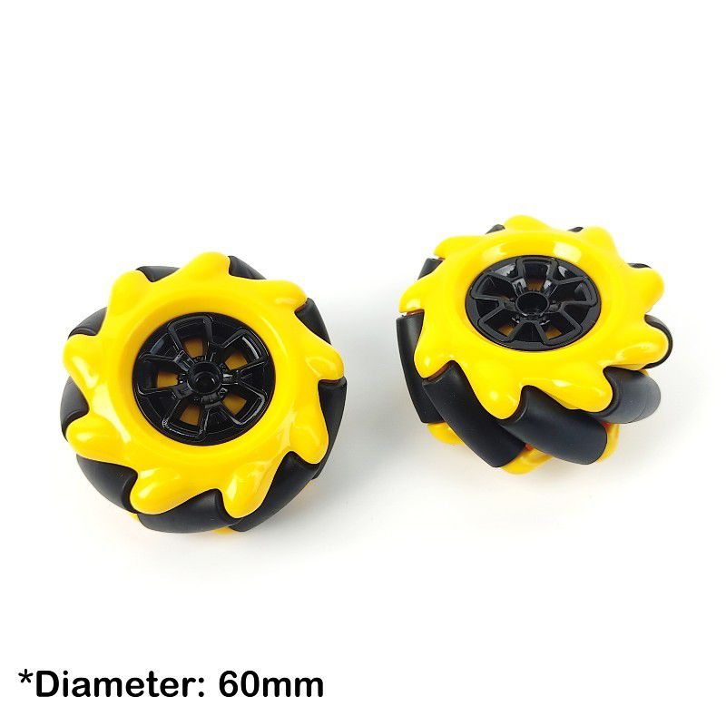
Mecanum wheels are special wheels that allow a robot to move in any direction without rotating the body. These wheels have small rollers fixed around the wheel rim at a 45° angle.
Each roller is free to rotate, so when the wheel spins, the roller creates a force that has two components:
- forward/backward force
- sideways force
That is why mecanum robots can do side movement (strafing).
A robot usually uses 4 mecanum wheels, and the rollers are mounted in opposite direction (X-pattern arrangement).
Working Principle :
Each wheel generates a force at an angle.
When all 4 wheels rotate in specific direction, their forces combine.
Robot Motions Possible
- Forward Movement
All wheels rotate forward → robot moves forward.
- Backward Movement
All wheels rotate backward → robot moves backward.
- Sideways Movement (Left / Right)
Left-side wheels rotate opposite to right-side wheels → robot slides sideways.
- Diagonal Movement
Only two wheels rotate or different wheel speed combination → robot moves diagonally.
- Rotation in Same Place
Left wheels forward + right wheels backward → robot rotates around center.
Control Requirement (Important Point)
Mecanum robots require:
- accurate RPM control
- encoder feedback
- PID speed control
- good motor driver
If one motor is weak, robot movement becomes unstable (drift issue).

Mechanical Requirements :
- Equal weight distribution is necessary.
- Wheels must touch ground equally.
- Strong chassis required.
- Suspension can improve performance.
Advantages :
- No need for steering mechanism.
- Perfect for narrow spaces.
- Smooth turning without changing direction.
- Excellent for factory automation.
Disadvantages :
- Slipping occurs on dusty floor.
- Efficiency is low because force is split.
- Rollers break faster due to friction.
- Needs high torque motors.
- Not good for outdoor uneven ground.
Applications (More Realistic Examples)
- AGV in warehouses
- hospital medicine delivery robots
- robotics competitions (Robocon, FRC)
- automated luggage transport in airports
Real World Example :
Many warehouse robots and industrial AGVs use mecanum drive to move sideways in narrow aisles and adjust position precisely while picking items.

5. Track Wheel / Tank Track
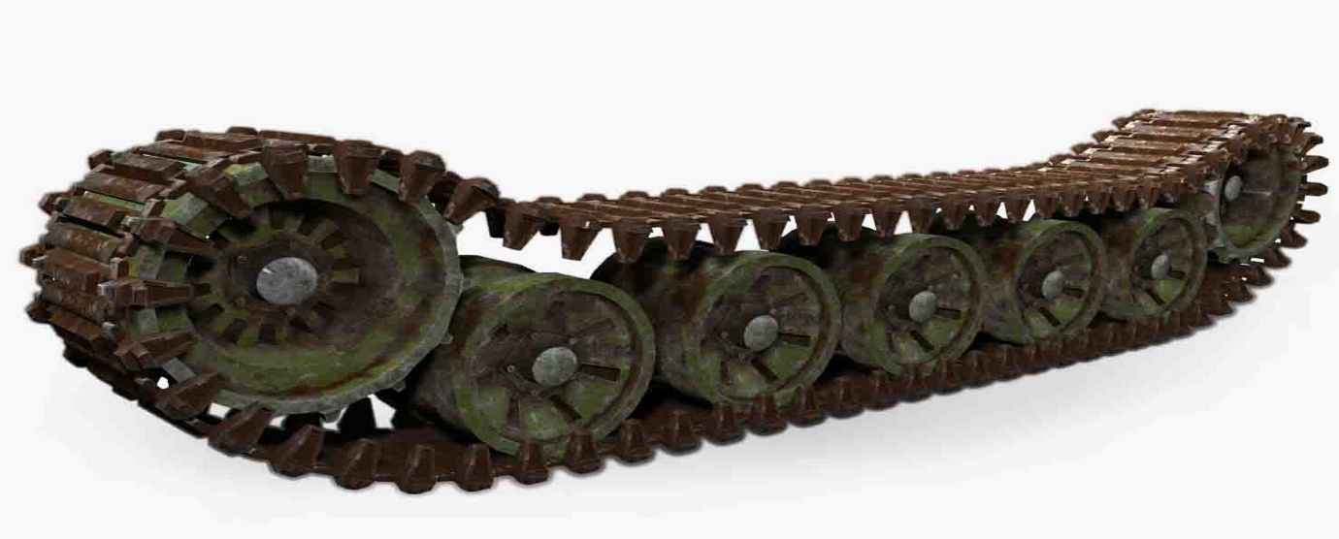
Tank tracks use a continuous belt system instead of a single wheel. The belt rotates around:
- front sprocket wheel
- rear sprocket wheel
- support rollers (optional)
Tracks provide maximum surface contact, so friction is high.
Working Principle
Motor rotates the sprocket wheel.
Sprocket teeth grip the track belt and pull it forward.
Because track touches ground on large area, it produces:
- high traction
- better load distribution
This is why tank robots do not sink easily in mud/sand.
Turning Mechanism
Tracks use differential turning:
- left track rotates faster than right → robot turns
- left forward + right backward → robot rotates in place
Design Factors
- Track tension is critical (too tight = motor overload, too loose = slipping).
- Track material can be rubber, steel, polymer.
- Requires strong motor torque.
Advantages
- Can carry heavy loads easily.
- Very stable on slopes.
- Less chance of wheel slip.
- Good for obstacle climbing.
Disadvantages
- Track belt wears out.
- Not suitable for smooth indoor tiles (friction is too high).
- Harder to maintain and replace.
- Requires more battery power.
Applications
- defense robots
- bomb disposal robots
- disaster rescue robots
- mining robots
- agricultural field robots
Real World Example
Robots like PackBot (military bomb disposal robot) use tracks because they must climb stairs and move safely on debris.
- Pneumatic Wheel (Air-Filled Wheel)
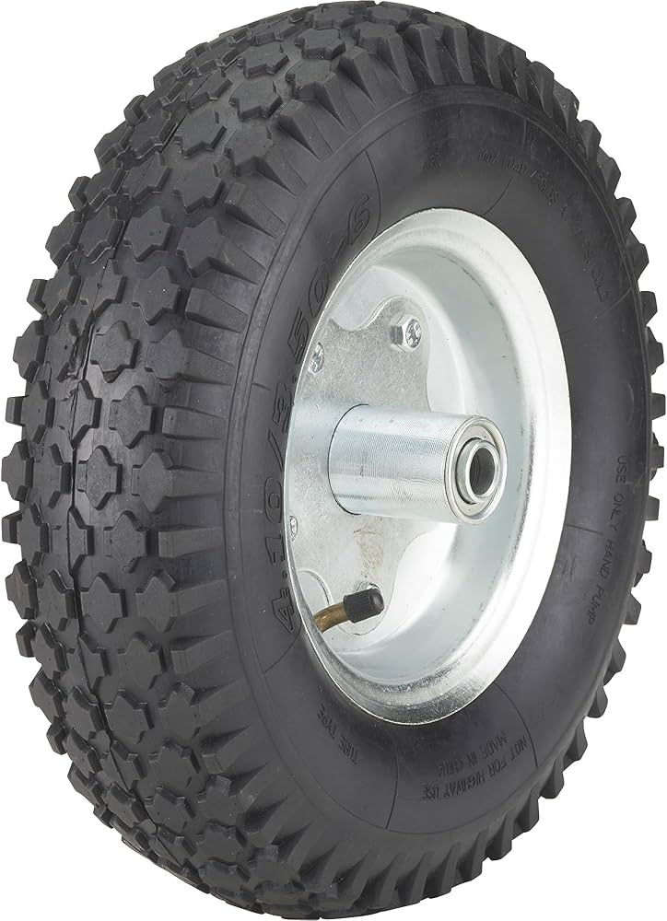
Pneumatic wheels are filled with compressed air and have a rubber outer tire. These wheels provide:
- shock absorption
- vibration damping
- comfort movement
This is extremely important in robots carrying sensors like:
- camera
- LiDAR
- GPS module

Working Principle
Air inside tire works like a spring.
When wheel hits a stone or bump:
- air compresses
- energy is absorbed
- robot body experiences less shock
This increases robot lifespan.
Important Technical Factors
- Tire pressure affects grip and stability.
- Low pressure = more grip but slower speed.
- High pressure = faster speed but less shock absorption.
Advantages
- Protects electronics from vibration.
- Better grip on grass and soil.
- Can support heavy robots.
Disadvantages
- puncture risk
- needs periodic air filling
- more expensive than plastic wheels
- not suitable for high precision indoor robots
Applications
- farm robots
- outdoor delivery robots
- patrol robots
- inspection robots for roads and bridges

Real World Example
Many agricultural robots like field monitoring bots use pneumatic wheels because they must move on uneven soil.
7. Ball Wheel / Ball Caster Wheel
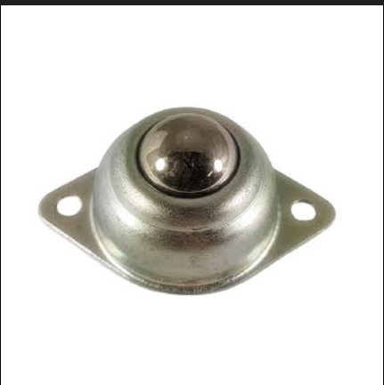
Ball caster is a support wheel that contains a metal or plastic ball inside a housing. It can rotate freely in all directions.
This wheel is used in:
- 2 wheel robots (for third support)
- 4 wheel robots (for extra balance)
Working Principle
When robot moves, the ball rotates in the same direction.
The ball reduces friction because it does not drag like a fixed skid.
Advantages
- cheap
- easy to mount
- improves robot stability
- allows smooth turning
Disadvantages
- dirt can jam the ball
- not good for grass and sand
- ball wheel reduces speed slightly
Application Examples
- line follower robots
- Arduino obstacle avoiding robots
- robotic vacuum cleaner
Real World Example
Shopping carts and old computer mouse used similar ball-type movement mechanism.
8. Magnetic Wheel
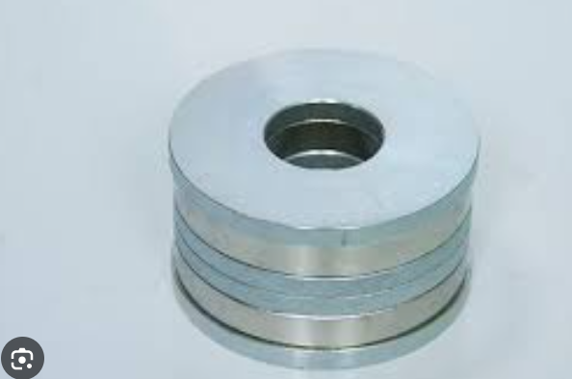
Magnetic wheels contain permanent magnets or electromagnets. These wheels allow robots to move on metallic surfaces such as:
- pipelines
- steel tanks
- ships
- bridges
These wheels are critical in industrial inspection.
Working Principle
Magnetic attraction produces normal force (downward pull).
Higher normal force increases friction, so wheel grip becomes strong.
That’s why robot can climb vertically.
Types of Magnetic Wheels
1. Permanent Magnet Wheel
- always magnetic
- no power needed
- simple design
2. Electromagnetic Wheel
- magnet ON/OFF control possible
- needs battery power
- used in advanced robots
Advantages (Extra)
- prevents slipping on vertical walls
- safe climbing movement
- stable in windy environment
Disadvantages (Extra)
- cannot work on aluminum or non-magnetic surfaces
- dust reduces magnetic contact
- heavy due to magnet weight
Applications
- oil pipeline inspection
- nuclear plant inspection robots
- ship hull cleaning robots
- bridge crack inspection robots
Real World Example
Oil and gas companies use magnetic crawler robots to inspect corrosion in pipelines.
9. Screw Wheel / Helical Wheel
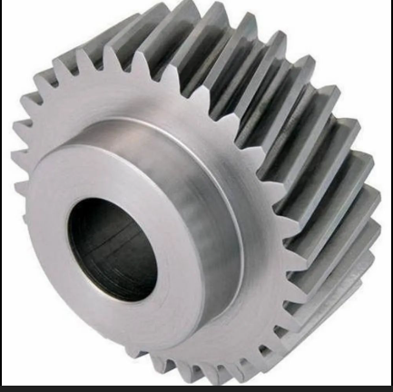
Screw wheel is a cylindrical wheel with spiral blades like a screw thread. It is mainly used for soft ground where normal wheels fail.
Working Principle :
When screw rotates, its blades push the soil backward.
Due to Newton’s 3rd law, soil pushes robot forward.
This is similar to how:
- boat propeller moves water
- drill pushes forward in wood
Best Surface for Screw Wheels
- snow
- sand
- mud
- marsh area
Advantages
- better than tracks in deep mud
- does not sink easily
- can move even in loose sand
Disadvantages
- cannot move on tiles and concrete properly
- causes vibration
- heavy mechanical design
- difficult manufacturing
Applications
- arctic snow robots
- mud rescue robots
- experimental Mars exploration rovers
Real World Example
Some research robots used in Antarctica use screw wheels for snow travel.
10. Swivel Wheel (360° Rotating Wheel)
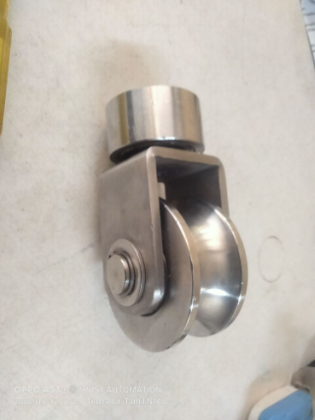
Swivel wheel is like caster wheel but stronger. It has a wheel mounted on a rotating joint which can turn 360°.
It is mostly used in heavy load platforms.
Working Principle
The swivel joint automatically aligns with direction of robot movement. When robot changes direction, wheel rotates and aligns.
Advantages (Extra)
- supports heavy weight
- smooth turning
- low maintenance

Disadvantages (Extra)
- not suitable for precise navigation
- wheel can wobble at high speed
- sometimes causes vibration
Applications
- trolley robots
- hospital equipment moving robots
- industrial carts
11. Spiked Wheel
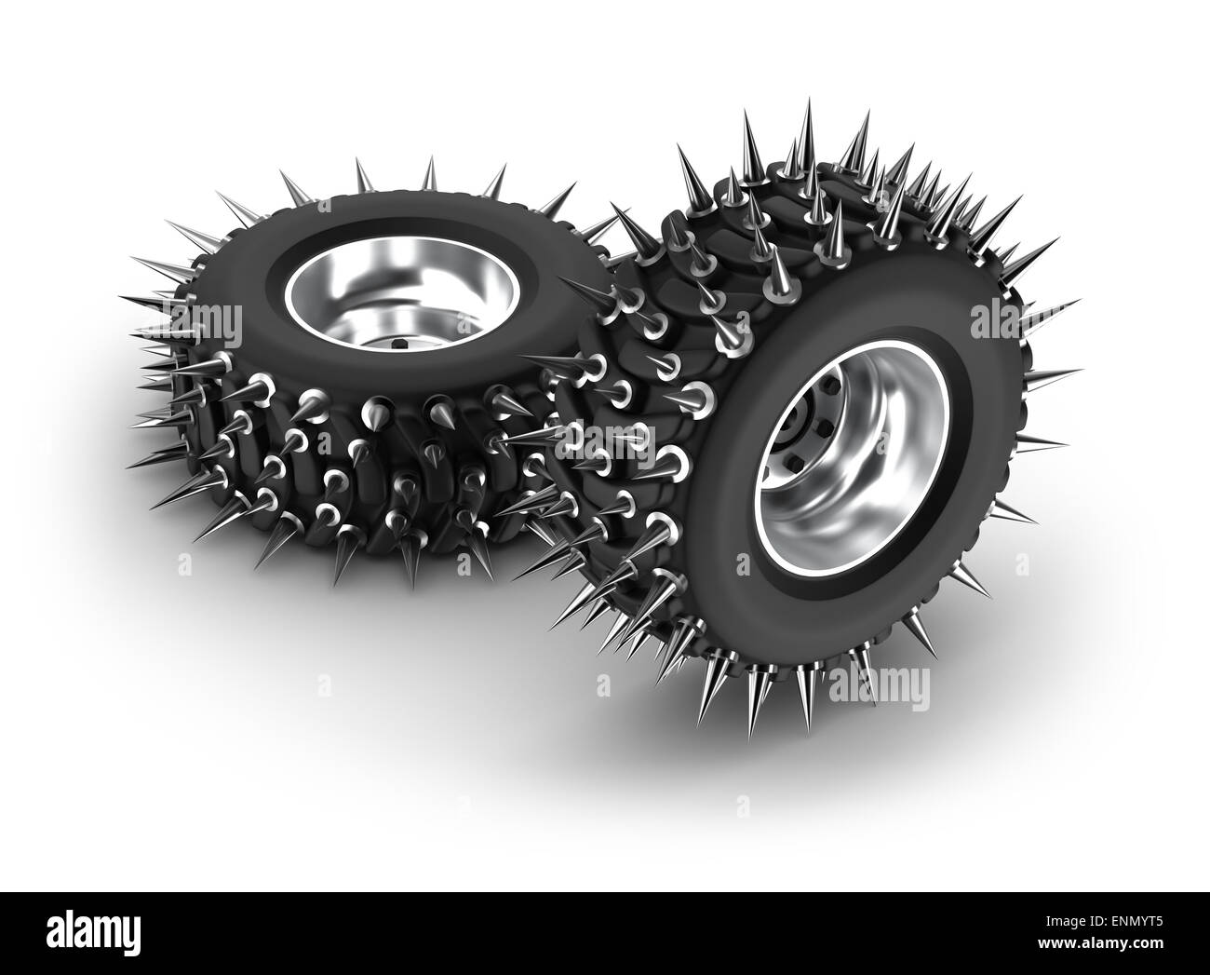
Spiked wheels have spikes or teeth that dig into ground surface. They provide very high grip.
These wheels are designed for environments where slipping is common.
Working Principle
Spikes penetrate the surface and create mechanical locking.
This reduces slipping even on steep surfaces.
Advantages (Extra)
- high traction
- good for climbing
- strong grip on grass and mud
Disadvantages (Extra)
- damages floor surface (not indoor friendly)
- noisy operation
- not suitable for smooth tiles
Applications
- stair climbing robots
- battle robots
- off-road exploration robots
Real World Example
Many combat robots in competitions use spiked wheels for pushing power.
12. Dual Wheel / Twin Wheel:
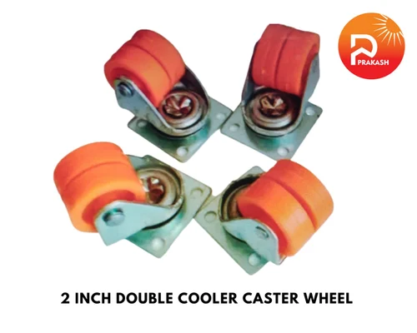

Dual wheel means two wheels mounted together on one side. It increases stability and distributes load.
Example: Instead of one wheel on left side, two wheels are used.
Working Principle
Load gets distributed across both wheels, reducing pressure on single wheel and improving balance.

Advantages
- higher load capacity
- stable motion
- reduced chance of wheel sinking in soil
Disadvantages
- more space required
- increases friction
- increases turning radius

Applications
- heavy transport AGV robots
- warehouse load carrier robots
- industrial moving platforms
14. Suction Wheel (Vacuum Wheel)
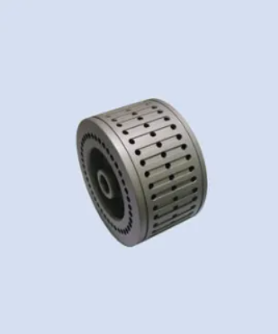
Suction wheels use vacuum suction to stick to smooth surfaces like glass or polished metal.
Working Principle
Vacuum pump creates low pressure region, which generates suction force.
Applications
- glass wall cleaning robots
- window inspection robots
15. Leg-Wheel Hybrid (Wheel + Legs)
Description
Some robots use wheels with leg mechanism. Wheels are used on flat ground, and legs activate on stairs/rocks.
Example
Boston Dynamics type robots and advanced rescue robots.
Conclusion (More Professional)
Wheel Selection Depends On:
- surface type (indoor/outdoor)
- load weight
- required speed
- required precision
- cost of project
- power consumption
Best Wheels by Environment
Smooth Indoor Floor
- Rubber wheels
- Omni wheels
- Mecanum wheels
- Swivel wheels
Rough Outdoor Terrain
- Pneumatic wheels
- Tank tracks
- Spiked wheels
- Screw wheels (special cases)
Industrial AGV / Warehouse
- Mecanum wheels
- Omni wheels
- Dual wheels
Climbing / Inspection Robots
- Magnetic wheels
- Suction wheels

